Curriculum Expectations
By the end of Gr. 4 students will…
Listening
- determine meaning in a variety of oral French texts, using appropriate listening strategies.
- interpret messages accurately while interacting in French for a variety of purposes and with divers audiences.
Speaking
- communicate information and ideas orally in French, using a variety of speaking strategies and language suited to the purpose and audience.

Materials
Students are expected to bring to every class their:
- Pencil case
- Agenda
- French Binder
- French Books (including their French/English Dictionary and Bescherelle)

Assessment
Students will be assessed based on their:
- Oral Comprehension
- Oral Communication
- Written Communication
- Reading Comprehension
Students will be assessed using:
- Presentations
- Quizzes/Tests
- Assignments/Projects
*Assessment dates will be written in student agendas and posted online.

Gr. 4 Extended French
Aaron Polowin| a.polowin@theojcs.ca | Room 220
- participate in spoken interactions in French for a variety of purposes with diverse audience.
Reading
- determine meaning in a variety of French texts, using a range of reading comprehension strategies.
- identify the purpose(s) and characteristics of a variety of adapted and authentic text forms.

Writing
- write in French in a variety of forms and for a variety of purposes and audiences, using knowledge of vocabulary and stylistic elements to communicate clearly and effectively.
- use the stages of the writing process to develop and organize content, clarify ideas and expression, correct errors, and present their written work effectively.
Intercultural Understanding
{through oral French texts, in their spoken communication, by reading French texts, and in their written work}
Demonstrate an understanding of information about aspects of culture in French-speaking Ontario communities and of French socio-linguistic conventions used in a variety of situations and communities.

Thematic Units
Unité 1: L’école
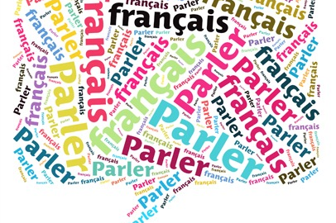
This short unit reviews vocabulary of school materials, people in the school, days of the week, months of the year, and other basic French vocabulary. Students will also review how to use their French/English dictionaries.

Classroom Expectations
The students have created our classroom expectations:
- Respect others
- En français
- Work well with others
- Raise your hand
- Come prepared and on time
- Respect our environment
- Listen and stay focused
- Help others
- Try your best
- Have fun!

Grammar
- Personal Pronouns
- Plural form of noun(s)
- Present tense of avoir, être, avoir, aller, faire, and pouvoir
- Present tense of “er” verbs
- Futur proche
- Negative form “ne…pas”
- Subject/verb agreement
- Agreement of definite and indefinite articles
- Regular adjectives with nouns
- Possessive adjectives
- Demonstrative adjectives
- Comparative form of adjectives
- Using questions words, “est-ce que”, and rising intonation
- Use and position of adverbs
- Preposition of place and “de” to indicate possession
Unité 2: La famille
Students will continue to develop their reading comprehension strategies with the study of the book “Andréanne et sa famille.” Vocabulary will focus on family relational names. Students will present their family tree as a final task.
Unité 3: La communauté
In this unit, students will examine French speaking communities in Ontario. They will also learn how to use their bescherelle. As a final task, students will create a pamphlet of an assigned community.
Unité 4: La maison
Students will explore concepts of space, function, furniture, and design of a home. They will have the opportunity to compare, describe, and offer ideas about homes and floor plans. Students will design and present a home created based on needs and wants of established characters.

